Experiment Title: Design of Wien bridge oscillator using operational amplifier

Aim/Objective: To design Wein bridge oscillator and analyze the desired frequency of oscillation in audio frequency range.

Description:

This arrangement causes the output waveform to shift by zero degree during its course of travel from output terminal to the base of the transistor. Therefore, this signal shall have a zero-phase shift in the feedback network. For satisfying the oscillation condition. The generalized expression for the frequency of oscillations produced by a Wein Bridge oscillator is given as follows.
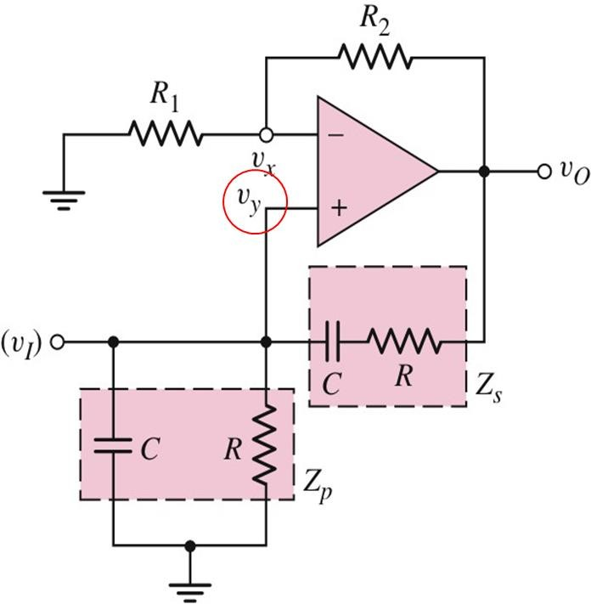

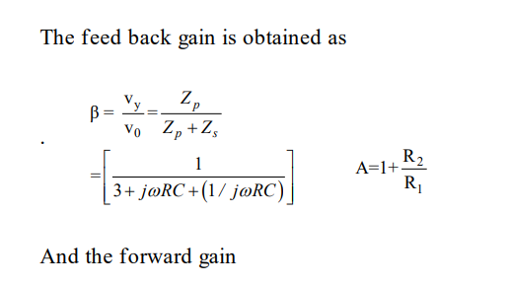

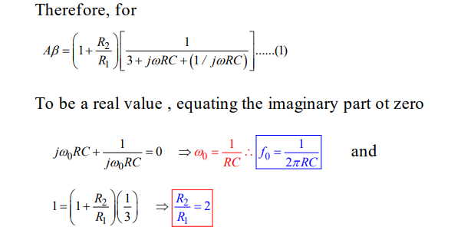

Pre-Requisites:
  - Study the data sheet of IC 741.
  - Identify the triggering for initial oscillations.
  - Determine Wein bridge components and OP-AMP feed-back and series resistances. Design procedure:
- Choose C
- Obtain suitable R depending on f ₀ = 1/2πRC
- Choose suitable R₁
- Obtain R₂=2 R₁

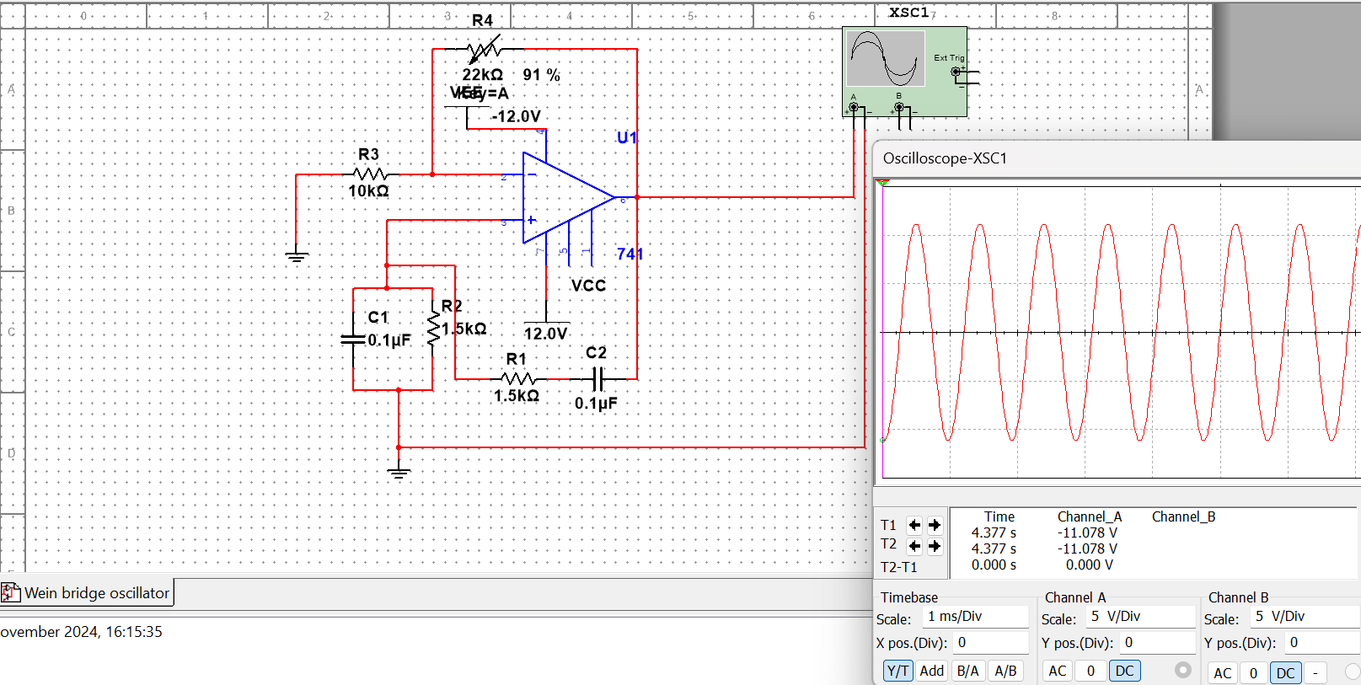
Procedure:

Data and Results:

SNO | R | C | Observed frequency
1
2
3

Analysis and Inferences:

VIVA-VOCE Questions (In-Lab):
- . The basic amplifier in Wein bridge oscillator consists of a: CE stage followed by CC
b: CC stage followed by CE
c: CB stage followed by CE d: CE stage followed by CB

- In a Wein bridge oscillator, the RC elements of the bridge provide a a: No feedback
b: Negative feedback
c: Negative feedback at low frequency d: Positive feedback
- The crystal oscillator frequency is very stable due to of the crystal
a: Rigidity
b: Vibrations c: Low Q
d: High Q
- In an LC oscillator, the frequency of oscillator is L or C.
a: Proportional to square of b: Directly proportional to
c: Independent of the values of
d: Inversely proportional to square root of
- In a phase shift oscillator, the frequency determining elements are …………
a: L and C
b: R, L and C c: R and C
d: None of the above

Post-Lab Session Case Study: Wein Bridge Oscillator for 5 kHz frequency
Objective: Design a Wein Bridge Oscillator for 5 kHz frequency.

Result: The Wien bridge oscillator using operational amplifier is successfully designed.

Evaluator Remark (if Any): | Marks Secured out of 50
Evaluator Remark (if Any): | Signature of the Evaluator with Date

